**MGT1061 – Digital Assignment 1**

**Marketing Management**

**Team 5:**

Yasir Ahmad 22MIA1064

Naveen N 22MIA1049

Namansh Singh Maurya 22MIA1034

Vishal Y. L 22MIA1073

Abhijay Anoop 20MIA1033

**SWOT Analysis for Fruit Juice Brand with Declining Sales**

**Situation**: Your fruit juice brand has experienced three consecutive years of declining revenue and profit, despite an 8.9% annual market growth. This indicates a significant gap between your brand's performance and the overall market trend.

To diagnose the root causes and formulate remedial actions, let's conduct a SWOT analysis:

A SWOT analysis involves assessing the Strengths, Weaknesses, Opportunities, and Threats related to a business or a specific situation.

**SWOT:**

|  |  |
| --- | --- |
| Strengths | Weakness |
| * Brand Recognition * Established distribution network * 100% Natural | * **Small product portfolio** * **Pricing strategy** * **Inefficient Production Methods** |
| Opportunity | **Threat** |
| * Health and wellness trend * Sustainability focused customer segments * Awareness against carbonated/aerated drinks. | * **Increased competition** * **Changing customer preferences** * **Rising Production cost** * **Low Entry Barrier** |

**Strengths:**

* **Brand recognition**: Our brand might have established recognition within the fruit juice market, providing a base for potential revival.
* **Product quality**: Focus on using high-quality ingredients and maintaining stringent processing standards to differentiate our product.
* **Distribution network:** Existing distribution channels offer a readily available infrastructure for reaching consumers.
* **Natural Fruit**– The juice’s unique selling proposition is that it contains no additives and is created from real fruit combined with an equal amount of water.

**Weaknesses:**

* **Product portfolio:** Limited variety or lack of innovation in flavors and offerings might be leading to customer churn.
* **Pricing strategy:** Uncompetitive pricing compared to rivals could be impacting sales volume.
* **Production costs:** Inefficient production processes or high sourcing costs could be squeezing profit margins.
* **High Investment in Packaging**– Since real fruit juice contains no additives, preservatives, or other artificial agents, the company must invest heavily in determining packaging technologies to keep its drinks fresh and of high quality. To keep the beverage’s shelf life, it must overcome distribution channel management challenges.

**Opportunities**

* **Health and wellness trend:** Capitalize on the growing consumer focus on health and wellness by highlighting the natural ingredients and nutritional benefits of our juices.
* **Convenience trend:** Offer innovative packaging formats or subscription services to cater to busy lifestyles.
* **Untapped market segments:** Explore expanding into new demographics or niche markets with tailored offerings.
* **Sustainability:** Embrace sustainable practices in sourcing, packaging, and production to resonate with environmentally conscious consumers.
* I**ncrease in Social Networking**– The global population of social media users has increased. The three social media networks with the largest monthly active user increases are Facebook, Twitter, and Instagram. Company may utilize social media to promote its products, engage with customers, and solicit feedback.

**Threats**

* **Increased competition:** New entrants and established players with aggressive marketing strategies could pose a challenge.
* **Low Entry Barrier**: The fruit industry has a low entrance barrier, and competition comes in all shapes and sizes. Small and medium-sized firms can enter and cater to the market with ease.
* **Rising costs:** Fluctuations in fruit prices, packaging materials, and transportation can impact profitability.
* **Changing consumer preferences:** Evolving taste preferences towards alternative beverages like smoothies or plant-based milks could threaten market share.

**Remedial Measures:**

Based on the SWOT analysis, here are some implementable remedial measures:

* **Revamp marketing strategy:**

Fruit Juices have established themselves as healthy product but younger generation of people a lured by the cool and adrenaline inducing ads of aerated/carbonated drinks with their catchy lines. Our ad campaigns don’t appeal to this younger customer segments.

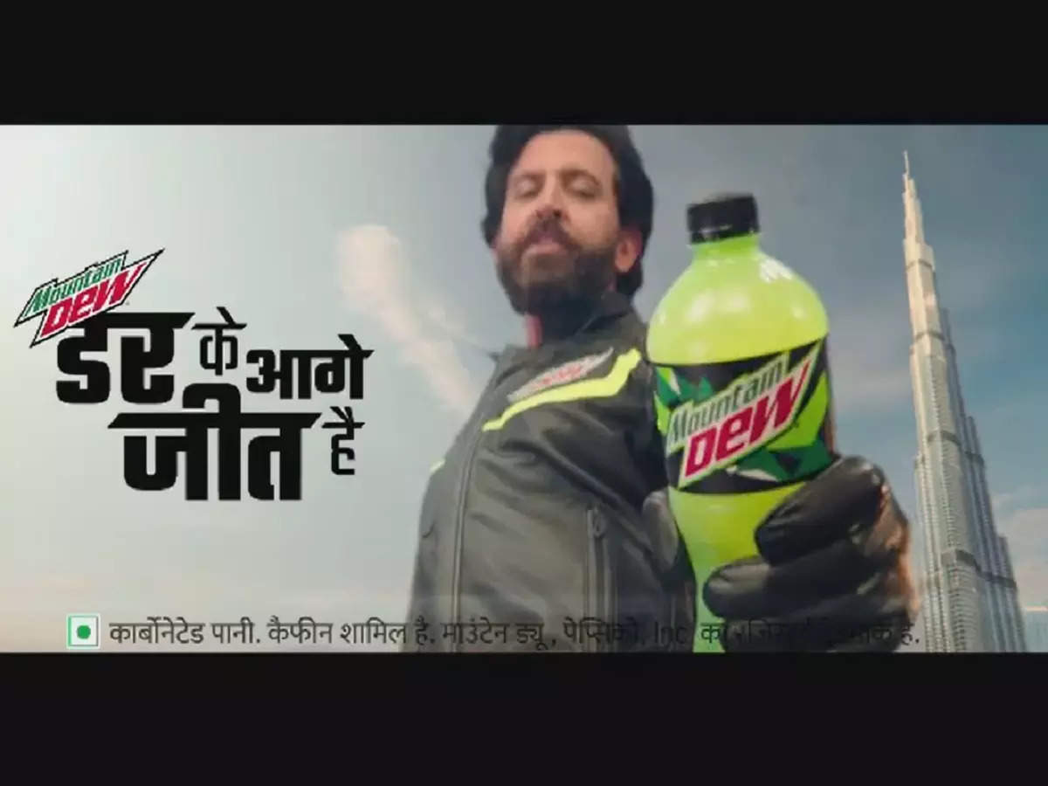 

Advertisement campaign of soft drinks

**Solution:** Conduct market research to understand current consumer preferences and tailor our messaging accordingly. Invest in digital marketing channels and consider social media influencer partnerships to reach a wider audience. New ad campaigns need to be targeted towards consumers of age group 16-30.

* **Innovate product portfolio:**

Our product portfolio has been the same for last 2 years, with no new innovative flavours added. The competitors have taken the lead in this aspect.

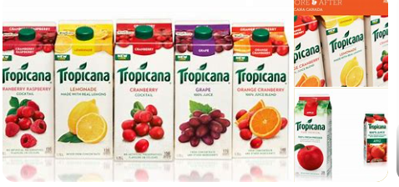 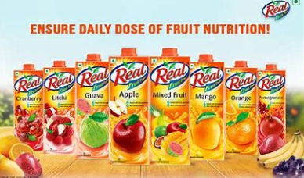

Product range of our competitors

**Solution:** We need to introduce new flavors, blends, or functional juice options to cater to diverse tastes and health goals. Explore cold-pressed, organic, or fortified juice options to stand out. To stand out of the crowd, produce specialized drink mix for athletes and gym workouts.

* **Optimize pricing strategy:**

The pricing strategy needs to be changes as we are offering only 1 Liter packets at high price.

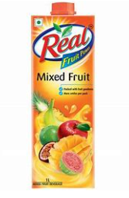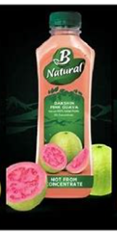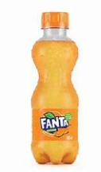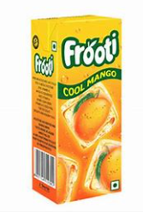

Different products at different prices

**Solution:** Launch different packs for every price range. “Frooti” and “Tropicana” have already launched Rs20 small packets and have proved that it is sustainable. Give consumers different pricing and volume options as not every time one would like to buy 1 Liter of juice.

* **Collaborations:**

There are lots of opportunities to get screen time by collaborating with event organizers and celebrities, sponsoring athletes, etc .

 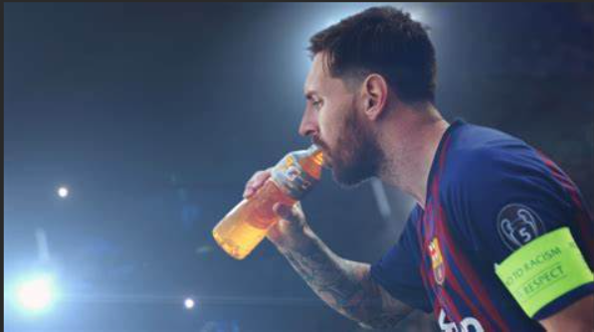

Messi drinking Gatorade Energy Drink ( FCB’s Jersey Sponsor)

IPL Sponsored by Pepsi



Red Bull’s Partnership with Honda to run Formula 1 racing team

**Solution:** Explore partnerships with influencers or health and wellness experts to endorse your product. Collaborate with retailers for special promotions or exclusive offerings. Sponsor public events and sporting competitions.

* **Embrace sustainability and Zero Waste Initiatives:** Invest in eco-friendly packaging materials, source fruits from sustainable farms, and emphasize our commitment to environmental responsibility in marketing campaigns. Implement zero-waste initiatives by using eco-friendly packaging materials and encouraging customers to return and recycle containers. Consider offering incentives for customers who participate in recycling programs.